2016-2017 REQUEST FOR FUNDING 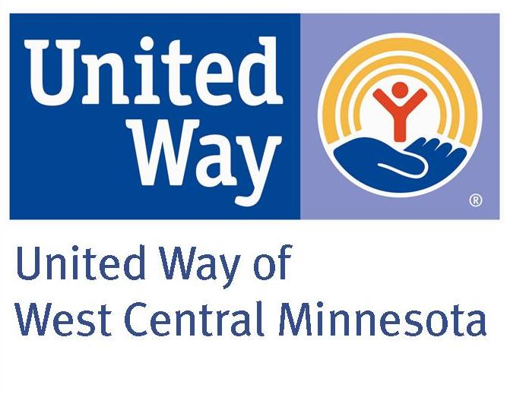

DATE OF APPLICATION:
LEGAL NAME OF ORGANIZATION:
ADDRESS:
CITY: |  |  |  | STATE: |  |  | ZIP:
PHONE: |  |  |  | EXT: |  |  | E-MAIL:

CONTACT PERSON FOR THIS GRANT |  | TITLE:
CONTACT PERSON FOR THIS GRANT |  | PHONE: |  | EXT:
EMAIL

EXEC DIRECTOR |  | PHONE: |  | EXT:
ORGANIZATION DESCRIPTION (2-3 sentences; please include total annual budget)
Please give a brief summary of your organization including 1) mission statement, 2) goals and 3) history.

Is your organization an IRS 501 (c) 3 not-for-profit? | Yes No
If no, is your organization a public agency, unit of government, school or religious institution?
If no, name of fiscal agent (fiscal sponsor):
Has your organization received a grant in the past year from United Way of West Central MN?

SUPPORT REQUESTED:
Program Name |  | Applying under which category
Program Budget |  | Total amount Requested

Please complete sections 1-5 for the program for which you are applying.
SECTION 1: BACKGROUND
Describe current programs/activities you provide to fulfill your mission.

What is your organization’s relationship with other organizations working to meet the same needs or providing similar services in West Central Minnesota? Please describe how you complement, work with, or differ from these agencies:

Related to Program applying for:
Number of board members:
Number of full-time paid staff:
Number of part-time paid staff:
Number of volunteers:

SECTION 2: DEMOGRAPHICS
Total number of people that directly receive services through the program(s) for which you are requesting support:

***Please be sure to enter a number (even if it’s “0”)  in each box to ensure proper totaling of numbers. |  | # persons served in past year | Anticipated # of persons to be served under request
Kandiyohi County | Atwater-56209
 | Blomkest/Svea-56216
 | Hawick-56246
 | Kandiyohi-56251
 | Lake Lillian-56253
 | New London-56273
 | Pennock-56279
 | Prinsburg-56281
 | Raymond-56282
 | Spicer-56288
 | Sunburg-56289
 | Willmar-56201
Meeker County | Cosmos-56228
 | Grove City-56243
 | Litchfield-55355
 | Darwin-55324
Renville County | Bird Island-55310
 | Danube-56230
 | Olivia-56277
 | Renville-56284
 | Sacred Heart-56285
Swift County | Benson-56215
 | Clontarf-56226
 | Danvers-56231
 | Kerkhoven-56252
 | Murdock/DeGraff-56271
Chippewa County | Clara City-56222
 | Maynard-56260
 | Other
 | TOTALS | 0 | 0

Is there any other demographic information that you’d like to share?

Will United Way funding be used as leverage in applying for other grants?
If yes, how and where is the funding being used?

Will you be applying for additional funding grants?
If yes, where are you applying and the amount requested?

Does your agency participate in “GIVE TO THE MAX” Day?
If so, how much was contributed on that day?

Please share one or more recent short success story. (Note, these stories may be shared publically by United Way)

SECTION 3: PURPOSE OF GRANT

SITUATION
Explain the problem, need, opportunity, and the community you propose to address:

ACTIVITIES
What are the program’s overall goals?
What activities will meet those goals?
Who will carry out those activities?
What is the program time frame?
How would you spend this grant?
How will this program benefit the community?
How will you sustain this effort?
Is your request for capital equipment? | Yes No
If yes, please explain how capital request relates to operation of your program?

SECTION 4: EVALUATION
What are the planned results for this program?
What indicators will be used to evaluate the program’s effectiveness?
Who will conduct evaluation? When, and how?
How will evaluations be used?

SECTION 5: SUPPLEMENTARY FUNDRAISING
What additional fundraising will your organization conduct for the upcoming year (i.e. annual appeal, special events, sales)?

**Organizations that receive funding from United Way of West Central Minnesota agree NOT TO FUNDRAISE during United Way of West Central Minnesota’s campaign (September 1 – October 15).**

Name & title of individual completing this form:

Name:

Signature: ________________________________________________________ Date:
Title:

ATTACHMENTS REQUIRED:
- Project Budget, including income and expenses (form attached).
- Most recent IRS 990 (If required to file).

PROGRAM BUDGET

***Please be sure to enter a number (even if it’s “0”) in each box to ensure proper totaling of numbers.

INCOME

 |  | Prior Year | Current Year | Next Year (projected)
Grant from this United Way
Support
 | Grants from other United Ways
 | Grants (Corp, Gov’t, Foundation)
 | Individual contributions
 | Fundraising events and products
 | In-kind support
Program fees
Revenue
 | Membership dues
 | Other (specify)
 | Other (specify)
 | TOTAL INCOME | $ 0.00 | $ 0.00 | $ 0.00

EXPENSES
 | Prior Year | Current Year | Next Year (projected)
Salaries and wages (breakdown by individual position)
Rent and utilities
Equipment
Supplies
Insurance, benefits and other related taxes
Consultants and professional fees
Travel
Printing and copying
Telephone and fax
Postage and delivery
In-kind expenses
Other (specify)
Other (specify)
TOTAL EXPENSE | $ 0.00 | $ 0.00 | $ 0.00

Difference (Income less Expense)
*this will not auto-calculate

