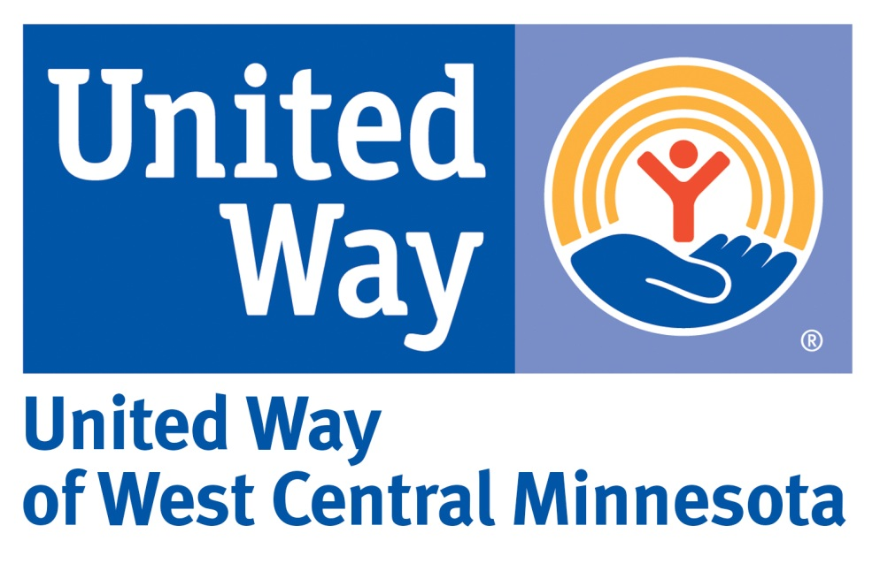
VOLUNTEERISM SCHOLARSHIP APPLICATION
United Way of West Central Minnesota will be awarding two $500 and four $250 scholarships to six area high school seniors who are making a positive impact in their communities through volunteerism.

Applications are due by 4:00pm on Monday, March 14th, 2018
Can be found at our website www.liveunitedwcm.org
Send by E-Mail: james@liveunitedwcm.org
or mail to : United Way of West Central Minnesota
PO Box 895
Willmar, MN 56201

Requirements are as follows:
- Student must be a high school senior graduating in the spring of 2018 from Willmar, NL-S, KMS, MACCRAY, RCW, BOLD, Litchfield, ACGC, Benson, Community Christian School in Willmar, Dream Technical Academy or Central MN Christian school and be entering post-secondary education.
- Have a home address that is within the United Way of West Central Minnesota territory, which includes the following Zip Codes: 56222, 56260, 56201, 56209, 56216, 56246, 56251, 56253, 56273, 56279, 56281, 56282, 56288, 56289, 55324, 55355, 56243, 56228, 55310, 56230, 56277, 56284, 56285, 56226, 56215, 56231, 56252, and 56271.
- Show a strong commitment to community volunteerism.
- Scholarship award winners will need to provide a photo and release for newspaper and/or social media use.
- *Only typed applications will be accepted.

All applications will be checked for eligibility and be reviewed by United Way volunteers who will select the finalists to be recommended to the United Way Community Investments Committee who will choose the scholarship recipients.
* Please note that scholarship awards are sent directly to the college or technical institute.

Name __________________________________________________________________
Address ________________________________________________________________
Enrolled high School ______________________________________________________
Please answer the following questions.
- List your volunteer activities and the type of volunteer work performed:

- Please list references where you have performed volunteer services:

- Tell us about one of your volunteer experiences and the impact it had on you.
(Please keep your answer to 500 words or less)

- Why do you feel it is important to volunteer?
(Please keep your answer to 500 words or less)

